Create a new project : reacttemp

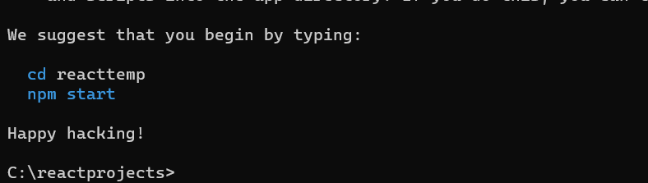

We will use a template which we had already used in assignment 3

[CLICK HERE TO DOWNLOAD TEMPLATE](https://drive.google.com/file/d/1sD0E5xfboMCRQWdI65k493yLZ3sJ5kmX/view?usp=sharing)

Extract above template

Copy and Paste CSS / Js / Asset folder in public.html of our react project.

Above template to → public folder of our react project

Copy Js links / js code / css links from

Index.html ( template ) → public ( index.html )

Create 2 folders inside src folder

1. Pages
2. Common

FILE 1 / PAGE 1 : Home.html ( template ) | Home.js ( React )

HEADER => Common ( header.js as it is present in all pages )

HOMEBANNER => Pages => Home.js ( Create new component Homebanner and use it in Home component )

HOMEINFO => Pages => Home.js ( create new component Homeinfo and use it in home component )

GALLERY => ( suppose it is common / used in multiple pages => Common ( gallery.js )